Report for: | Cabinet
Date of Meeting: | 16 February 2023
Subject: | Consultation on Borough wide Public Space Protection Order (PSPO).
Key Decision: | Yes – borough-wide impact
Responsible Officer: | Dipti Patel - Corporate Director of Place;  Cathy Knubley - Director of Environmental Services
Portfolio Holder: | Councillor Anjana Patel - Portfolio Holder for Environment & Community Safety
Exempt: | No
Decision subject to Call-in: | Yes
Wards affected: | All Wards
Enclosures: | Appendix 1 – Proposed PSPO for consultation  Appendix 2 – Existing PSPO Borough wide  Appendix 3 – Existing PSPO Town Centre

Section 1 – Summary and Recommendations
This report seeks approval to undertake a consultation on a new Public Spaces Protection Order (PSPO) to cover the Borough, pursuant to powers as set out in the Anti-Social Behaviour, Crime and Policing Act 2014, to address matters of Anti-Social Behaviour (defined as activities that have a detrimental effect on the quality of life to those in the locality)
Recommendations:
Cabinet is requested to:
- Consider the content of the draft Public Spaces Protection Order and approve an 8-week consultation on this; and
- Agree that the outcome of the consultation is brought back to Cabinet to consider along with any changes to the draft PSPO as a result, which can then be considered for adoption

Reason (for recommendation):
The PSPOs would allow direct action against low level anti-social behaviour, with the benefit of being able to issue fixed penalty notices for breaches, if appropriate.

Section 2 – Report

Introduction.
2.1 Harrow Council is committed to improving the environment, maintaining low crime, reducing anti-social behaviour and improving community safety. Directly relating to this commitment is the Councils action to address anti-social behaviour and related complaints.

2.2 Introduction of a Public Spaces Protection Order (PSPO) is a power given to local councils under the Anti-Social Behaviour, Crime and Policing Act 2014.

2.3 PSPOs are intended to deal with a particular nuisance or problem in a specific area that is detrimental to the local community’s quality of life, by imposing conditions on the use of that area which apply to everyone. They are intended to help ensure that the law-abiding majority can use and enjoy public spaces, safe from anti-social behaviour.

2.4 An overview of the process is shown below, taken directly from the Official Guidance that accompanies the legislation.
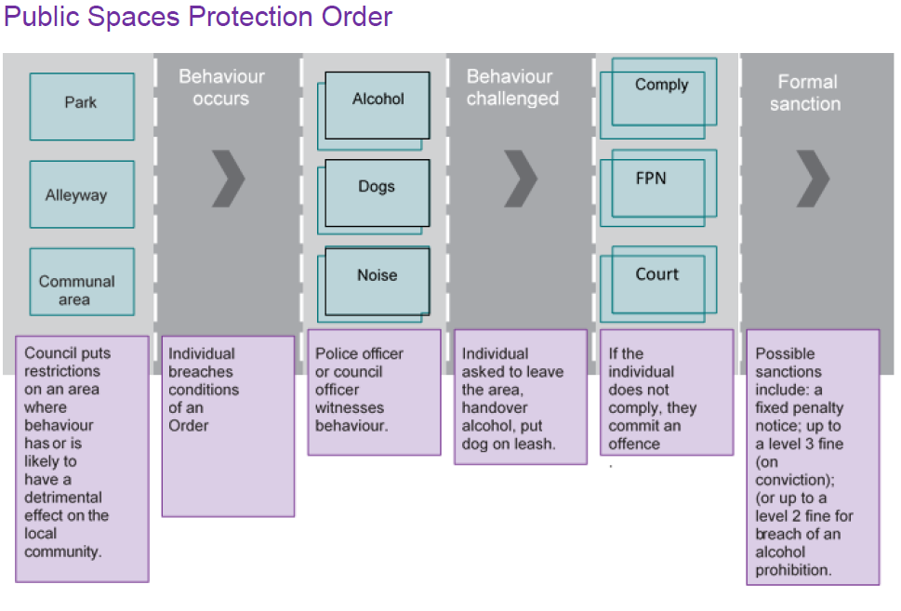

2.5 The Council can make a PSPO if satisfied, on reasonable grounds that the following conditions are met in relation to the activities sought to be regulated:
- That they are or are likely to be carried on in a public place within the Borough;
- That they have had, or are likely to have, a detrimental effect on the quality of life of those in the locality;
- The effect, or likely effect of the activities is likely to be, persistent or continuing in nature;
- Is or is likely to be such as to make the activities unreasonable; and
- justifies the restrictions sought to be imposed by the order

2.6 As with all the anti-social behaviour powers, due regard should be given to issues of proportionality: is the restriction proposed proportionate to the specific harm or nuisance that is being caused? It is essential that the restrictions being introduced are reasonable and will prevent or reduce the detrimental effect continuing, occurring, or recurring.

2.7 In addition, the Order must be appropriately worded so that it targets the specific behaviour or activity that is causing nuisance or harm and thereby having a detrimental impact on others’ quality of life.

2.8 Failure to comply with a PSPO is an offence and can lead to a summary conviction and fine not exceeding level 3 on the standard scale. In February 2015, the Council agreed that a Fixed Penalty (FPN) of £100 could be applied to any non-compliance with a PSPO if appropriate, rather than a prosecution. However, for repeat offenders or in cases where it is believed the issuing of a FPN would not deter future action, or if the offender fails to pay the FPN, a prosecution may be taken. A person authorised by the Council, a Police Officer and / or a Police Community Support Officer (PCSO) if authorised can enforce the PSPO.

2.9 In line with the normal approach taken with the PSPOs already in place, as well as other matters of low-level environmental significance, education and engagement will be the initial approach, which involves explaining to those potentially breaching the PSPO what the requirements are and how to meet them. Persistent offenders or those who refuse to heed advice will lead to escalation.

2.10 If, after consultation, a PSPO is approved then information will go on the Council Website, be publicised through local and social media, new signage will be erected in relevant areas and our comms team will help to maximise publicity of the Order.

2.11 Any PSPO can last a maximum of 3 years, although it can be extended if necessary, and/or reviewed (and varied or discharged) during the course of its life. In this case, the proposed PSPO is sought for 3 years.

2.12 Currently there are two active PSPOs in the Harrow, a Borough wide PSPO which is in effect until January 2024 (Appendix 2) and a Town Centre PSPO which is in effect until July 2024 (Appendix 3). The proposal is to replace both of these orders with a single PSPO to cover the Borough and the specific areas of concern identified.

2.13 The current PSPOs have been reviewed in relation to action taken for each offence. In 2022 a total of 6,158 offences were witnessed related to the PSPO, each of these offences resulted in a fixed penalty notice being served on the offender.

 | 2022
PSPO-Amplification | 26
PSPO-Birds feeding | 44
PSPO-Dog fouling - failure to carry a bag | 68
Littering-Cigarette | 2313
PSPO-Defecating | 4
PSPO-Dog Fouling | 4
PSPO-Street Drinking | 403
PSPO-Driving over footpath | 2402
PSPO-Financial Agreement in street | 1
Littering-Food | 40
PSPO-Leaflets | 21
PSPO-Obstruction | 6
Littering-Other | 91
Littering-Printed Literature | 13
PSPO-Smoking in parks | 12
PSPO-Spitting | 425
Littering | 64
LLA-Street Trading | 173
PSPO-Street trading | 7
PSPO-Tables stand without permission | 10
PSPO-Urinating | 31
Total: | 6158

2.14 Enforcement activity over the last year demonstrates that these anti-social behaviours still exist and that there is a place for enforcement.

2.15 Prior to drafting the proposed PSPO (which can be found in Appendix 1) information and evidence was gathered across several Council Departments and also from key partners. This was used to identify where there was prima facie evidence of anti-social behaviour in a public place of a continuing nature. The proposed PSPO has been drafted to include each of these.

2.16 Partner Engagement which took place with:
- Highways
- Parks and green spaces
- Police
- Business Improvement District
- Community Safety
- Housing
- Other stakeholders including park user groups and Councillors

2.17 This was to ensure a comprehensive list of all issues within the Borough. Partners were asked to provide evidence of the issue, and this was provided in the format of:
- Data of reported issues
- Social media reports of anti-social behaviour
- Anecdotal information from officers & residents who have witnessed the anti-social behaviour of had this reported to them
- Enforcement action undertaken in relation to these areas
2.18 Appendix 1 is the proposed content of the new PSPO which will now be consulted on to ensure residents and businesses are aware of the content and support the need for these restrictions to help address anti-social behaviour.

2.19 The purpose of the consultation is to take all these matters to residents and businesses to assess whether these issues are happening in a persistent way across the Borough and whether this is causing nuisance. Only where residents support this will the offences be put forward for adoption in the final draft.

What are the activities that the proposed PSPO seeks to address?

2.20 In recent years Harrow has seen a rise in low level crime and antisocial behaviour including but not limited to:
- Groups of mainly men loitering and drinking in public places,
- Litter and waste being dropped or left behind on the street
- Delivery waste and food packaging left in any open spaces
- Dog control and fouling related incidents in alley and streets
- Dogs out of control, causing nuisance in Parks and Nature reserves
- Attacks and harassment of wildlife
- Fly tipping and litter from vehicles
- Nuisance vehicles and vehicle repairs in the street
- Issues with delivery drivers riding and parking on pavements
- General anti-social behaviour in parks and open spaces

2.21 As with all enforcement, this is about having the powers to tackle individuals who will not engage with a reasonable request and not simply about targeting generally law-abiding members of the public.

2.22 A PSPO should not be a blanket ban or set of restrictions it should be bespoke to the issues in each area. In light of this the proposed PSPO looks to address anti-social behaviour in five areas:
- issues that are common throughout the Borough,
- issues that occur in our housing estates
- issues that occur in parks and open spaces
- issues that occur in our town centres
- issues that occur in Bentley Priory

2.23 For the Whole Borough the following areas are being proposed for requirements/prohibition
- Street drinking while engaged in anti-social behaviour
- Occupying any vehicle or caravan
- Consumption, use, and/or possession of psychoactive substances
- Controlling and clearing up after dogs
- Provide your name and address
- Urinating/defecating and/or spitting in public
- Careless disposal of cigarettes and other material
- Highways and Vehicles
- Smoking in Play Areas
- Illegal advertising or running events
- Fires and fireworks
- Congregating groups engaged in anti-social behaviour

2.24 For housing estates the following areas are being proposed for requirements/prohibition

- Obstructing the entrances to or exit from any building, or the free passage of people on or in stairwells
- Causing an obstruction which prevents or hinders the free passage of pedestrians or vehicles
- Unroadworthy vehicles
- Fly-tipping
- Bird feeding

2.25 For all parks and green spaces (including Bentley Priory) the following areas are being proposed for requirements/prohibition
- Littering
- Dog Control
- Driving vehicles on park land without prior permission
- Unauthorised activities
- Bird feeding

2.26 For the identified town centres (Harrow Town Centre, Pinner, Stanmore, Wealdstone, Harrow on the Hill, Hatch End, Rayners Lane, Belmont & South Harrow) the following areas are being proposed for requirements/prohibition
- Intimidating and/or aggressive begging
- Obstructing access to business premises during opening hours
- Leaving commercial waste in public spaces for an unreasonable length of time
- Use of amplification
- Financial Agreements on the Street
- Placing of tables, stands, or other furniture / fixings
- Distribution of leaflets
- Illegal or Unauthorised Street Trading
- Feeding of Birds and Vermin

2.27 For Bentley Priory, Pinner Memorial Park and the Viewpoint the following areas are being proposed for requirements/prohibition
- Dog control Bentley Priory
- Feeding of Birds
- Indecent behaviours and damage to grass areas Viewpoint

2.28 Bentley Priory is a recognised site of special scientific interest (SSSI) and a nature reserve. It has been identified as a location where nuisance and anti-social behaviour has been on the rise, and it is essential that protections are put in place to ensure that visitors and wildlife are protected from the recurring issues. Therefore, the proposal here is that dogs are required to be on a lead at all times.

2.29 The consultation will run for eight weeks. The consultation will be undertaken with our communication and engagement colleagues, be published on the Harrow Consultation webpage and promoted through social media.

2.30 Correspondence will be sent to relevant parties to the PSPO including charities or representatives of affected groups. We will correspond by letter or email to at least the following:
*Park user groups
*Selection of resident associations
*Dogs trust
*RSPB
*Town Centre BID
*Local chamber of commerce/Other appropriate business representatives
*Harrow Angling Society
*London Anglers association
*Homeless charities
*Other Neighbouring Authorities & the GLA

2.31 We will also undertake a consultation day in each of the town centres listed in the PSPO, Harrow Town Centre, Pinner, Stanmore, Wealdstone, Harrow on the Hill, Hatch End, Rayners Lane, Belmont & South Harrow.

2.32 The consultation stage will be focused on identifying whether residents and business have experienced this anti-social behaviour and if this is Borough wide or in specific parts of the Borough. Following the close of the consultation the PSPO will be specifically worded to the issues in Harrow and will progress restrictions where the consultation supports the need for the implementation and the legal grounds are satisfied for adoption.

  - The final proposed PSPO will be brought back to Cabinet following the close of consultation to be considered for adoption.

Performance Issues

2.34 There are no performance implications.

Environmental Implications

2.35 The PSPO is expected to have a hugely positive impact on the Environment, by putting in place a proactive scheme that addresses matters evidenced within the area.

2.36 By having clear requirements in place, backed up by the means of a timely penalty for non-compliance (Fixed Penalty Notices), it allows matters that affect the environment to be addressed in a more efficient and effective means and hopefully leading to longer term behavioural changes.

Data Protection Implications

2.37 There are no data protection implications.

Risk Management Implications
2.38 Risks included on corporate or directorate risk register? No

Separate risk register in place? No

The relevant risks contained in the register are attached/summarised below. n/a
The following key risks should be taken into account when agreeing the recommendations in this report:

Risk Description | Mitigations | RAG Status
Reputational risk  Residents and businesses do not support the proposed PSPO. | Following the close of the consultation the PSPO will be specifically worded to address the issues in Harrow and will only progress restrictions where the consultation supports the need for their implementation and the legal grounds are satisfied for adoption. | GREEN

Procurement Implications
2.38 There are no implications.

Legal Implications

2.39 The Council can make a PSPO pursuant to the Anti-Social Behaviour Crime and Policing Act 2014 (“The Act”) if satisfied, on reasonable grounds that the following conditions are met in relation to the activities sought to be regulated:
- That they are or are likely to be carried on in a public place within the Borough;
- That they have had, or are likely to have, a detrimental effect on the quality of life of those in the locality;
- The effect, or likely effect of the activities is likely to be, persistent or continuing in nature;
- Is or is likely to be such as to make the activities unreasonable; and
- justifies the restrictions sought to be imposed by the order
2.40 A PSPO prohibits, or requires, things to be done in an area or for both – i.e. prohibit and require, but these must be to prevent or reduce the detrimental effect in the area. A PSPO can be limited to apply by time/circumstances etc but must be clear to understand what is required and/or prohibited. The legislation sets out the requirements for the content of a PSPO and publication requirements that must be followed.

2.41 Under Section 60 of the Act, a PSPO cannot have effect for longer than 3 years unless extended.

2.42 Sections 62 and 63 covers aspects relating to PSPOs prohibiting the consumption of alcohol.

2.43 Sections 64 and 65 deal with orders restricting public rights of way over the highway.

2.44 Section 66 specifically provides an interested party (as defined in the Act) the ability to challenge the validity of a PSPO, or its variation, by application to the High Court. The grounds for such a challenge are that the local authority did not have the power to make or vary the order or include certain prohibitions/requirements, or that a requirement under the relevant part of the Act was not complied with.

2.45 There is a 6-week time limit to make such an application from the date of the order or variation. Pending full determination, the High Court can suspend the operation of the order, or variation. Upon determining the application, the Court, if it finds that the authority did not have the power to do what it did/required under the order, or that the interests of the applicant have been substantially prejudiced by a failure to comply with a requirement of the Act in relation to PSPOs, can quash or vary the order or any prohibitions or requirements under it.

2.46 When considering any proposed PSPOs, the authority must consider any equality issues pursuant to its duty under section 149 of the Equality Act 2010.

Financial Implications

2.47 The cost of consultation will be met from within Licensing & Enforcement service budget.

2.48 The approval of the new PSPO will be subject to a further Cabinet report. If approved, the enforcement shall be carried out within the service as well as the use of the Council’s third-party enforcement contractor which operates on the basis of at no cost to the Council.

Equalities implications / Public Sector Equality Duty
2.49 The Council has a statutory duty to comply with the provisions set out in the Equality Act 2010 (“The 2010 Act”).
2.50 In summary, under section 149 of the 2010 Act the Council must in the exercise of all its functions, “have due regard to” the need to comply with the three arms or aims of the general equality duty. These are to:
- eliminate discrimination, harassment, victimisation and any other conduct prohibited by the 2010 Act;
- advance equality of opportunity between people who share a protected characteristic and people who do not share it; and
- foster good relations between people who share a protected characteristic and people who do not share it.
2.51 Having due regard means to consider the above three aims of the Equality Duty as part of the process of decision-making and take steps to mitigate negative impacts on those with protected characteristics and can mean treating some people more favourably. This means that decision makers must be able to evidence that they have taken into account any impact of the proposals under consideration on people who share the protected characteristics before decisions are taken.
2.52 Any proposed PSPO is likely to have a positive impact on certain protected groups such as victims of hate (gender, sexuality, religious or disability) related ASB, it will apply to the whole population and its use will be determined by the behaviour occurring rather than the protected group.
2.53 There is an exception regarding young people, guidance suggests that a FPN can be issued to someone under 18 years of age but the current position at Harrow is that this will not happen.
2.54 A full Equalities Impact Assessment will be completed following the consultation. If the Council then considers whether to make the proposed PSPO, section 72 of the Act requires Cabinet as decision maker for this specific PSPO, to pay particular regard to rights of freedom of expression and freedom of assembly set out in articles 10 (the right to freedom of expression) and 11 (freedom of assembly and association) of the European Convention on Human Rights in considering the making any such order.
2.55 It would also have to be concluded that the making of the proposed PSPO was proportionate and would fulfil a legitimate aim of curbing anti-social behaviour in public places for the benefit of the law-abiding majority.
Council Priorities
2.56 The Harrow Council priority is to restore pride in Harrow by ensuring it is:
- A borough that is clean and safe
- A well drafted and fully consulted public space protection order will help to tackle antisocial behaviour which is having a detrimental effect on the quality of people’s lives. Introducing and enforcement of the order will help to tackle low level crimes, clean up and reclaim Harrow’s streets and public spaces, to enhance them and make them safer for residents, visitors and legitimate business operators.

Section 3 - Statutory Officer Clearance
Statutory Officer: Dawn Calvert
Signed by the Chief Financial Officer
Date: 07/02/2023
Statutory Officer: Baljeet Virdee
Signed on behalf of the Monitoring Officer
Date: 07/02/2023
Chief Officer: Dipti Patel
Signed off by the Corporate Director
Date: 07/02/2023
Head of Procurement: Nimesh Mehta
Signed by the Head of Procurement
Date: 06/02/2023
Head of Internal Audit: Neale Burns
Signed on behalf of the Head of Internal Audit

Date: 07/02/23
Has the Portfolio Holder(s) been consulted? Yes ☒

Mandatory Checks

Ward Councillors notified: NO, as it impacts on all Wards

EqIA carried out: This will be carried out once the consultation has ended and prior to the final proposed PSPO is brought back to cabinet

EqIA cleared by: N/A

Section 4 - Contact Details and Background Papers
Contact: David Gilmour, Enforcement Manager, David.Gilmour@harrow.gov.uk, tel. 07927548307
Background Papers:
- Anti-social Behaviour, Crime and Policing Act 2014
https://www.legislation.gov.uk/ukpga/2014/12/contents/enacted
- Anti-social behaviour powers Statutory guidance for frontline professionals
https://www.gov.uk/government/publications/anti-social-behaviour-crime-and-policing-bill-anti-social-behaviour
Call-in waived by the Chair of Overview and Scrutiny Committee - NO

